Building and deploying cdrlite

The National Cancer Institute’s (NCI) Comprehensive Data Resource (CDR) is a distributed web-based system that manages and maintains multi-dimensional data models on biospecimens. The CDR was developed and is currently utilized to collect biospecimen annotation and clinical data on biospecimens collected from cancer patient donors and post-mortem donors, for the NCI’s Biospecimen Pre-analytical Variables (BPV) and NIH Genotype-tissue Expression (GTEx) programs.
The CDR provides secure data access based on a user’s roles and privileges. Through dynamic content redaction, it protects private information in compliance with HIPAA regulations. Its graphic user interfaces streamline data entry workflow based on SOPs for sample collection and processing. The automated data checks and validations confirm data integrity and SOP adherence simultaneously.
More information can be found here:
http://biospecimens.cancer.gov/newsevents/news/07172015.asp
The CDR-Lite is a Grails application. To get this standalone version up and running, please follow the steps below. Prerequisites:
Knowlege of Java and Git is assumed.
Install the latest JDK 7 per instructions for your environment. JDK 8 is not supported at this time.
Install PostgreSQL 9.3
Create a database called cdr. Create a user and password. By default, the cdrlite will try to connect to the database as “cdr/admin.” The cdr user will not need any special privileges. Through hibernate, it will create tables and sequences only.
The database, user and password you create will need to be synchronized with DataSource.groovy which can be found in the conf folder under grails-app.

Install Grails 2.4.4 per instructions for your environment. Later versions of Grails are not supported at this time. Earlier versions may not be compatible. This is very important.
See here for more Grails installation information:
http://grails.org/doc/latest/guide/gettingStarted.html
Obtain the code by cloning from GitHub:
https://github.com/NCIP/CDR-Lite
After cloning from GitHub, open a console window, navigate to the cdrlite folder and run the following commands:
0) set JAVA_OPTS=-XX:MaxPermSize=128m -XX:PermSize=512m -Xms1024m -Xmx2048m (This is a generous estimate. Default memory settings are not enough.)
In your local environment, open the file
cdrlite/grails-app/conf/DataSource.groovy
Update the entries at
environments {
development {
dataSource {
To match the username and password you created in postgreSQL
1) grails RunApp
This will download all project plug-ins, resolve dependencies and determine if your environment is set up properly. If all goes well, you should see the following message: Server running. Browse to http://localhost:8080/cdrlite
2) Open a browser of your choice and enter http://localhost:8080/cdrlite
3) You may log in with the following test account:
admin/admin
If you run into errors, try the following:
1) Grails clean
2) Grails upgrade (say yes)
3) Grails RunApp
The CDR was originally developed in the NetBeans IDE against Oracle XE. This version is using PostgreSQL 9.3.

BUILD WAR FILE:
Make sure tomcat is not running within the Netbeans IDE before you start.
The wars batch script is found in the main project folder and is run from the MS-DOS command line prompt. The script executes a Grails command and builds the war file for a requested environment. An environment could be any one of the following: Production, Test, QA, DEV. Depending on the script options, the war file can be built for all or for any single environment. The environment definitions are found in cdrlite/conf/DataSource.groovy.
How to run the SCRIPT?

At the command line prompt change directory to the project folder:
C:\dev\svn\cdrlite>wars test (build war file for the test environment)
C:\dev\svn\cdrlite>wars (builds multiple war files for every environment)
* If applicationContext.xml not found error is seen, run “grails upgrade”.
*Please note: The above command may take a long time to complete (average time is about 3 -7 minutes per environment)
Naming convention for the war file:
The war file is built with the environment name and the current version appended to it. The war file(s) built from above step can be found in the target directory within the main project folder. The version number is read from the application.properties file found in the main project directory.
The war file in this example is built as version 3.5 and targeted for the ec2cdr environment:
cdrlite.war.ec2cdr-3.5

Update WAR file to the server:
Using WinSCP, remote copy the War file to the server for which it is built.
Example: In the case of test, login as ‘jenkins’ and copy the war file from the target directory to the /var/storage/old-webapps directory.
The Config.groovy and DataSource.groovy files for the correct environment will be embedded in the war file.

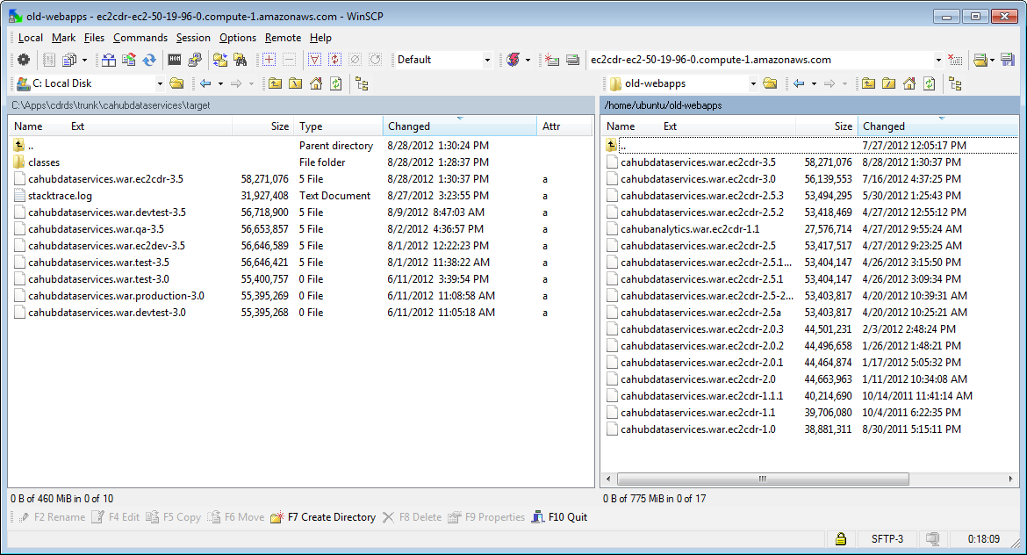

Steps to update the application on the server with the latest version
Using Putty, login via ssh to the server for which the War file has been built.
Open two sessions of putty so that the logs can be viewed on one, while the Tomcat server is being stopped and restarted on the other
On the first session (A), become root (sudo su -) and change directory upon logging in to: /var/log/tomcat7 and tail the log file: tail -200f catalina.out
On the second session (B), become root (sudo su -) and change directory to /var/lib/tomcat7/webapps. Set your session to root by typing sudo su – and entering the appropriate password. You need to be root to stop and start tomcat.
At this point, email to the team that the server is being stopped for deploying a new version.
Run the following commands on session B:
Make a copy of the current war file for fallback and recovery purposes:
/var/lib/tomcat7/webapps$ cp –p cdrlite.war cdrlite.war.backup.PEH.28-Aug-2012

Copy the war file from the {upload} dir (in this case /home/ubuntu/old-webapps) to the tomcat webapps dir.
Eg: /var/lib/tomcat7/webapps$ cp –p /home/ubuntu/old-webapps/cdrlite.war.ec2cdr-3.5 .

Check if tomcat is running
ps –aef | grep java
You should see something like:
tomcat7 3059 1 0 Jul08 ? 00:10:23 /usr/lib/jvm/java-7-oracle/bin/java -Djava.util.logging.config.file=/var/lib/tomcat7/conf/logging.properties -Xms2048m -Xmx2048m -XX:PermSize=512m -XX:MaxPermSize=512m -Djavax.sql.DataSource.Factory=org.apache.commons.dbcp.BasicDataSourceFactory -Djava.util.logging.manager=org.apache.juli.ClassLoaderLogManager -Djava.endorsed.dirs=/usr/share/tomcat7/endorsed -classpath /usr/share/tomcat7/bin/bootstrap.jar:/usr/share/tomcat7/bin/tomcat-juli.jar -Dcatalina.base=/var/lib/tomcat7 -Dcatalina.home=/usr/share/tomcat7 -Djava.io.tmpdir=/tmp/tomcat7-tomcat7-tmp org.apache.catalina.startup.Bootstrap start
Stop Tomcat
/etc/init.d/tomcat7 stop
(View the logs scrolling on the screen on the other opened session (A).)
Remove the old war file and the (exploded) project dir..
/var/lib/tomcat7/webapps$ rm –rf cdrlite.war
/var/lib/tomcat7/webapps$ rm –rf cdrlite
Copy the uploaded war file from its environment and version-specific name to something tomcat will recognize and deploy upon startup:
/var/lib/tomcat7/webapps$ cp –p cdrlite.war.ec2cdr-3.5 cdrlite.war

Start Tomcat again. This will deploy the war file and re-create the project directory in tomcat7/webapps/ .
/etc/init.d/tomcat7 start
Watch the scrolling logfile in session (A) and the output from “top” in session B. Scan for any stacktraces in the logs and keep an eye on the java process in top until the application server has completed startup. You should see the following message at the bottom of the log file in session A:
Configuring Spring Security ...
Configuring Spring Security LDAP ...
Configuring Spring Security UI ...
Aug 28, 2012 5:58:52 PM org.apache.coyote.http11.Http11Protocol start
INFO: Starting Coyote HTTP/1.1 on http-8080
Aug 28, 2012 5:58:52 PM org.apache.jk.common.ChannelSocket init
INFO: JK: ajp13 listening on /0.0.0.0:8009
Aug 28, 2012 5:58:52 PM org.apache.jk.server.JkMain start
INFO: Jk running ID=0 time=0/21 config=null
Aug 28, 2012 5:58:52 PM org.apache.catalina.startup.Catalina start
INFO: Server startup in 136410 ms
CHECK TO SEE IF APPLICATION IS RUNNING AND CHANGES HAVE BEEN IMPLEMENTED
Open your browser and navigate to the application URL on the server where the war file has been deployed. Check if application is running as expected and all the changes for this version are intact.
Noto Bene: In our environment, an apache proxy, a redirect and an SSL certificate are in place, so that http://cdrlite.ncifcrf.gov/ automatically takes the user to https://cdrlite.ncifcrf.gov/cdrlite/ . The scope of this document does not cover server configuration and administration, but you may wish to consider something similar in your installation environment. Such configuration is highly dependent on the environment where the application will be running.

This manual process has been replaced by an automated deployment tool, Jenkins, but the manual process will work, and documentation of the deployment tool is out of scope for this document.

